Name ____________________________________ Physics

Static Electricity Lab

**Goal**: To determine how charged objects relate to each other and to neutral objects.

**Materials:**

Small pieces of paper; (2) white vinyl strips; (2) acetate strips; (1) thick polyethylene strip; tape; set-up shown below; electroscope and static wand/fur

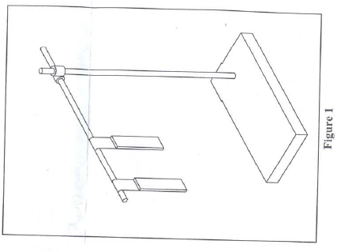**Pre-lab Questions:**

1. Do oppositely charged objects attract?
2. Is a neutral object attracted to a charged object?
3. What is the difference between induction and conduction

**Activity: (1) Is Neutral Attractive?**

1. Charge a white vinyl strip with paper
2. Charge a clear acetate strip with paper
3. Place each near a pile of cut small pieces of paper. What do you notice? ___________________________________________________________

___________________________________________________________

**Activity (2) The Hanging Strips**

1. Using a small piece of tape, hang each of the charged strip from a horizontal bar clamped to a ring stand. **Charge each strip. (repeat for each experiment)**
2. Charge another strip of each and bring them near the other strips (one at a time)
3. What happens when you being the same strips near each other? _____________________________________
4. What happens when you being the opposite strips near each other? _____________________________________
5. Take a pith ball (hung on fishing line) and bring it near each strip.
   1. What do notice when it is near the white strip? ____________________________________________
   2. What do notice when it is near the clear strip? ____________________________________________
   3. Charge the thick polyethylene strip with paper. This will be charged negative. Bring it near each of the hanging strips.
      1. What do notice when it is near the white strip? ____________________________________________
      2. What do notice when it is near the clear strip? ____________________________________________
   4. What can you conclude is the charge of each strip?
      1. White strip charge is __________________________________
      2. Clear Strip charge is ___________________________________

**Activity (3) Electroscope’s response to a charged object**

You will need an electroscope, a plastic static tube and a piece of rabbit fur.

1. Charge the plastic tube using the rabbit fur and bring it NEAR the electroscope, but do not touch it. What is the electroscope’s response? __________________________________________________
2. Move the plastic tube towards and away from the electroscope, what is the electroscopes response? _________________________________________________________________________________
3. The rabbit fur loses electrons to the plastic tube. Knowing this, what is the charge on the plastic tube? _________________. What is the charge on the rabbit fur? _______________________________.
4. Knowing the charge on the plastic tube, explain in terms of movement of electrons the behavior of the electroscope. ______________________________________________________________________

__________________________________________________________________________________.

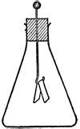

1. Draw a picture of the electron movement when the electroscope is near the plastic tube.

**Activity (4) Electroscope Demo (charging by Conduction and Induction)**

1. Charge the plastic tube as before using the rabbit fur. This time, bring it near the electroscope **and touch the wand to the metal head of the electroscope**. Move the plastic tube away from the electroscope. What is the electroscope’s response? ____________________________________________________________________________________
2. If the static wand is negatively charged, what is the charge of the electroscope? ___________________
3. Charge the plastic tube as before using the rabbit fur. This time, **bring it near the electroscope and place your finger on the metal electroscope head**. Remove your finger from the electroscope and move the plastic tube away from the electroscope. What is the electroscope’s response? ____________________________________________________________________________________
   1. If the static wand is negatively charged, what is the charge of the electroscope?

___________________

* 1. Move the plastic tube near the electroscope, what is the response of the electroscope? ___________________________________________________________________________.
  2. Explain why this occurs, using movement of electrons and the terms positive and negative.

____________________________________________________________________________________

____________________________________________________________________________________